**Review of Literature**

Polycystic ovary syndrome (PCOS) is the most common endocrine-metabolic disorder in women at their childbearing age accompanied by various symptoms and implications (Yadav *et al*., 2023; Akre *et al*., 2022). This syndrome is characterized by reproductive, metabolic, and endocrine abnormalities including hyperandrogenism, ovulatory dysfunction, infertility, higher occurrence of obesity, insulin resistance, hepatic steatosis, and dyslipidemia (Rodriguez Paris *et al*., 2022). It regards for 80% of infertility caused by anovulation (Li *et al*., 2024). Women with BMI >30 have approximately a 4-fold increased risk of developing impaired glucose tolerance (IGT) or type 2 diabetes mellitus (T2DM) resulting in a high prevalence of obesity (Ng *et al*., 2019). It is estimated that 21% of women at their reproductive age suffer from PCOS worldwide and India’s prevalence according to Rotterdam criteria is estimated to be 11.34% (Atiomo *et al*., 2024; Bharali *et al*., 2022). This condition is also called Sclerocystic Ovaries, Metacystic ovaries, or Stein Leventhal Syndrome which was named by two American gynaecologists Irving F Stein and Michael L. Leventhal in 1935 after they observed the irregularities in a series of seven women with amenorrhea, hirsutism, obesity, and histological evidence of polycystic ovaries (Siddiqui *et al*., 2022; Madnani N *et al*., 2013). The multiple diagnostic criteria of PCOS have evolved with several proposed criteria including the Rotterdam criteria (2003), the Androgen Excess and PCOS Society (AE-PCS) criteria (2006), the National Institutes of Health (NIH) criteria (2009), and the International Evidence-based Guideline for the assessment and management of PCOS. In Rotterdam criteria, 2 out of 3 conditions should be present i.e. :-(1) oligo-amenorrhea, (2) hyperandrogenism, (3) ultrasound of polycystic ovaries (an ovarian PCOS phenotype, O-PCOS) which results in four unique phenotypes as phenotypes A (called “classical” phenotype), B, C, and D (called “lean” phenotype) (Gleicher *et al*., 2022). Despite these apparent criteria, the underlying cause of PCOS is not known, and precise treatment techniques have not been established (Atiomo *et al*., 2024; Bednarska and Siejka, 2017). While medications exist for PCOS managing the symptoms often starts with making healthy lifestyle choices without the worry of side effects from medication (Malik *et al*., 2024). The current therapy mainly focuses on the management of symptoms and prevention of long-term complications including lifestyle modification, ovulation induction, anti-androgen therapy, and treatment of metabolic disorders (Liao *et al.,* 2021).

**Prevalence: -**

The prevalence of heterogenous endocrine disorder is 1 in almost 15 premenopausal women i.e. 6 to 20% globally. It depends on the region (rural or urban) and lifestyle (physical work and eating habits) of the individual. About half of the PCOS-affected individuals are obese and depict abdominal obesity which indicates the high levels of androgens that might increase adipose tissue in the abdominal region (Siddiqui *et al*., 2022). In the 1980s the use of ultrasound imaging revealed that PCOS was associated with hirsutism and hyperandrogenaemia with regular ovulatory cycles (Nidhi *et al*., 2011). Women with PCOS have insulin resistance and compensatory hyperinsulinemia are present in 44% to 70% which are more likely to develop T2D. In addition, Paediatric T2D disproportionately affects females and its rates increased among minoritized racial and ethnic groups (Cioana *et al*., 2022).

**Pathophysiology of PCOS: -** The pathophysiology is complex and reflects the interactions between genetic and environmental factors that contribute to hormonal imbalance combined with factors including obesity, ovarian dysfunction, and hypothalamic-pituitary abnormalities (Teede *et al*., 2010; Dumesic *et al*., 2015). The researchers suggest a familial aggregation of PCOS, with daughters of affected mothers exhibiting a 5-fold greater risk of inheriting the syndrome. Neonates born to PCOS mothers indicate prolonged AGD, potentially reflecting prenatal androgen exposure which presents with an elevated risk profile for metabolic dysregulation and androgen excess. Maternal testosterone levels concluded infant AGD in women diagnosed with PCOS (Mukherjee *et al*., 2023). Three main components contribute to the ill health of PCOS-affected women results declining their health-related quality of life (HRQoL): - (i) physical health issues such as adverse body composition, increased fat accumulation, diabetes, irregular menstrual cycle, and infertility; (ii) esthetical concerns such as acne, hirsutism, female pattern hair loss; (iii) psychological issues such as anxiety, depression, and disordered eating (Karjula *et al*., 2020). Genotype-phenotype correlation studies identified relevant findings: - In Han Chinese women with PCOS revealed that THADA and DENND1A variants were associated with endocrine and metabolic disturbances while in the population of European ancestry, DENND1A which is a variant near FSHR was observed to be a risk allele for androgen excess and anovulation and other variant near RAB5B was linked to impaired glucose metabolism, a precursor related to diabetes (Azziz *et al*., 2016). Factors include hyperandrogenism, ovulatory dysfunction, follicular arrest, aberrant gonadotropin-releasing hormone (GnRH) pulsation, and insulin resistance (Harada M., 2022).

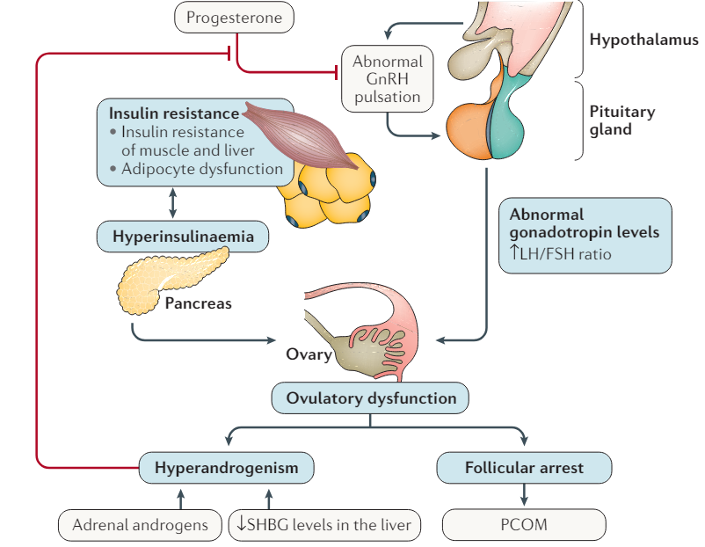

**FIGURE 1: - Pathophysiology of polycystic ovary syndrome (PCOS).**

**Hyperandrogenism: -** Testosterone exists in three primary binding states: - unbound (free) testosterone and testosterone bound to SHBG or albumin. The distribution typically follows a pattern of approximately 80% bound to SHBG, 19% bound to albumin, and only 1% remains unbound (free) testosterone (Ashraf *et al*., 2019). Excessive synthesis of androgen by the ovaries as well as adrenals results in hyperandrogenism (Singh *et al*., 2023). In PCOS, Androgens can cause stress within the egg-developing cells (granulosa cells) in the ovaries. This stress can lead to two things: - an increase in receptor sites for harmful sugar molecules (RAGE) and a buildup of these harmful sugar molecules (AGEs) within the ovaries (Szukiewicz *et al*., 2022). Enhanced estrone conversion to oestradiol may influence follicular development and promote an elevated LH: FSH ratio, potentially leading to ovulatory dysfunction (Sadeghi *et al.,* 2022).

**Ovarian follicular dysfunction: -** Oocytes secrete various inhibitory transcription factors serine/threonine kinase (LKB1, STK11, and BMP4). Additionally, it expresses proapoptotic factors like FOX and perform epithelial-mesenchymal interaction to control follicular growth in a quiescence state. Another key regulator of folliculogenesis is AMH, a factor produced by granulosa cells within small, growing follicles (Nautiyal *et al*., 2022). Women diagnosed with PCOS have elevated serum and FF concentrations of AMH. Increased serum levels of AMH in PCOS demonstrate positive correlation with elevated in testosterone and/ or LH concentrations which linked to alteration of oocyte maturation and resulting low quality of embryo. Furthermore, higher concentrations of AMH in FF of PCOS women are associated with higher percentage of immature oocytes, and lowering the fertilization rates during assisted reproductive procedures compared to women with endometriosis or pelvic adhesion syndrome (De Leo *et al*., 2016).

**Aberrant GnRH Pulsation: -** Immature oocytes mature and impact on various hormones, especially FSH, ovulation, and in addition final maturation occur upon LH stimulation (Azziz *et al.,*2016). LH is a gonadotropin secreted by anterior pituitary gland that binds to luteinizing hormone receptors (LHR) and it increases in PCOS patients due to a defective hypothalamic-pituitary-ovarian-axis (Sarahian *et al.,*2021). FSH stimulate the growth of ovarian follicles (6-8mm) acquire aromatase activity and may increase oestradiol. Hypersecretion of LH in PCOS women may activate premature meiotic processes that reduce the oocyte quality and results in formation of embryonic aneuploidies (De Leo *et al.,*2016).

**Hyperinsulinemia: -** Hyperinsulinemia exerts a modulatory effect on the pituitary gland. Accumulation of insulin may amplify the pulsatile release of GnRH and LH by impacting both the frequency and amplitude of their secretory pulses. This indirect effect of insulin on PCOS pathogenesis is further enhanced by GnRH neuronal activity and increased pituitary sensitivity to GnRH (Sadeghi *et al*., 2022). Insulin reveals a synergistic interaction with LH to extend androgen production within theca cells. This effect is mediated by the activation of a distinct signaling pathway downstream of its dedicated receptor (Dumesic *et al*., 2015). Elevated insulin levels not only promote fat accumulation (adiposity) but in severe cases, its mitogenic (cell growth-promoting) properties can lead to a condition resembling pseudoacromegaly. This seems to be a contradictory phenomenon existing alongside a hallmark of acquired obesity (Rosenfield R. L., 2020). Some women with PCOS have a greater phosphorylation-172-1 receptor substratum which inhibits insulin receptor signal. Fasting insulin levels are higher in women with PCOS and a first-degree relative with type 2 diabetes is more likely to have these abnormalities (Ding *et al*., 2021). Dalamaga M *et al.,* 2013 in a prospective controlled study of patients diagnosed with PCOS demonstrated that ovarian SAHA syndrome (seborrhea, acne, hirsutism, and androgenetic alopecia) is associated with a higher IR profile representing a risk factor independent for glucose abnormalities (Di Lorenzo *et al*., 2023)

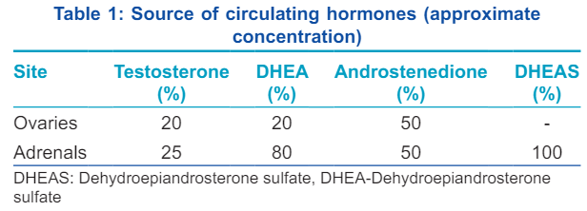

**Diagnosis:-**

The diagnosis of PCOS is typically established following menarche, coinciding with the onset of menstrual cycle dysfunction and the manifestation of clinical signs associated with androgen (T) excess (Barrett *et al*., 2018). Rotterdam conference in 2003 that established diagnostic criteria in which 2 out of 3 conditions should be present i.e. :-(i) oligo-amenorrhea, (ii) hyperandrogenism, (iii) ultrasound of polycystic ovaries (an ovarian PCOS phenotype, O-PCOS) which is classified based on clinical characteristics as phenotypes A (called “classical” phenotype), B, C, and D (called “lean” phenotype) (Gleicher *et al*., 2022). In classic PCOS, particularly phenotypes A and B, women experience more severe menstrual irregularities, higher insulin production, insulin resistance, and a stronger likelihood of developing metabolic syndrome. Phenotype C tends to have slightly higher levels of insulin, atherogenic lipids, androgens, and hirsutism while Phenotype D is characterized by normal levels of male hormones (androgens), but may have slightly higher levels of other hormones including high levels of a protein that binds sex hormones (sex hormone-binding globulin), low levels of thyroid hormones (T3 and T4), and a lower ratio of LH to FSH (Khan *et al*., 2019). Phenotypic distribution in epidemiological studies in an unbiased population for phenotype A and B combined is 40-45%, for phenotype C is -35%, and -20% for phenotype D (Azziz *et al*., 2016).

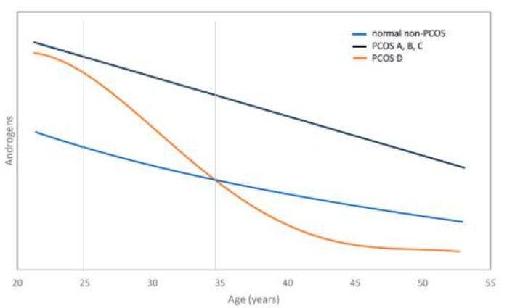

**FIGURE 2: - Schematic of androgen decline with advancing age in PCOS and non-PCOS women.**

**Genetics of PCOS: -**

The genetic basis of PCOS was first described by Cooper and colleagues in 1968. Family studies reported that PCOS is inherited in an autosomal dominant pattern and the prevalence in a first-degree relative of the proband was found nearly 50-60% and later on, it was identified as a monogenic cause of hirsutism and oligomenorrhea. **Studies in identical and fraternal twins estimated the heritability to be over 72% in women with PCOS (**Khan ***et al*.,2019) while Dutch twin studies suggested the heritability to be 0.79 among PCOS patients (**Goodarzi *et al*., 2011). Females prenatally exposed to elevated testosterone (T) levels due to maternal clinical conditions during pregnancy, such as congenital adrenal hyperplasia (CAH), particularly 21-hydroxylase deficiency, congenital virilizing tumors, or specific sex steroid pathway mutations, exhibit an increased risk of developing polycystic ovary syndrome (PCOS) in adulthood.Polycystic ovarian morphology (PCOM) has 12 or more cysts in the ovary measuring from 2 to 9 mm in diameter and/or ovarian volume >10 ml (Mukherjee *et al*., 2023; Dumesic *et al*., 2015). Candidate genes have identified many susceptibility genes including cytochrome P1A1 (CYP1A1), CYP11A, CYP17A1, CYP19, 17β-hydroxysteroid dehydrogenase (HSD17B6), androgen receptor (AR), sex hormone binding globulin (HSBG), insulin receptor (INSR), insulin receptor substrate 1 (IRS1), peroxisome proliferator-activated receptor gamma (PPAR-γ), follicle-stimulating hormone receptor (FSHR), luteinizing hormone / chorionic gonadotropin receptor (LHCGR), anti-Mullerian hormone receptor type 2 (AMHR2), interleukin (IL) IL-1A, IL-1B and IL-6 whereas genome-wide association studies have identified many susceptibility loci include THADA, DENND1A, LHCGR, FSHR, C9orf3, YAP1, GATA4 AND ERBB4 (Ganie *et al*., 2019).

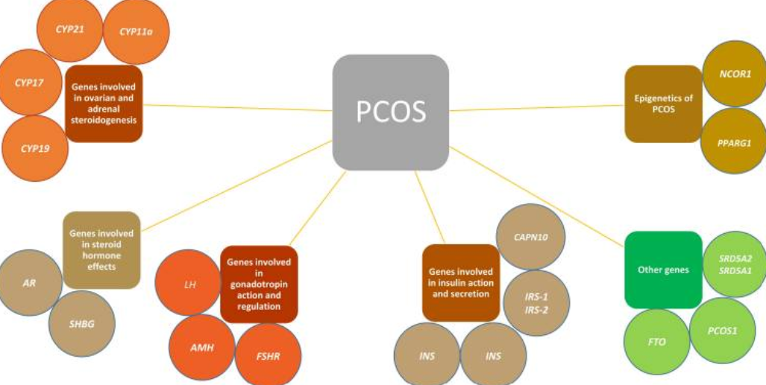

**FIGURE 2:-Summary of the genes involved in PCOS highlights the complexity of the disease.**

**Genes involved in ovarian and adrenal steroidogenesis:-**

Androgen overproduction is a common hormonal imbalance in PCOS. Researchers have investigated several genes potentially linked to this issue:-

* **CYP11A1:-** CYP11A1 is named as cytochrome P450, family 11, subfamily A, member 1 or cholesterol-desmolase. It is located on chromosome 15q24.1 and has 10 exons. CYP11A1 encodes superfamily of cytochrome p450 and present in mitochondrial inner membrane. The gene controls a key step in the catalysis of cholesterol to pregnenolone and also play role in steroidal synthesis pathway. SNP rs4077582 in CYP11A1 elevates androgen level through the regulation of Luteinizing hormone in various genotypes. Polymorphism in the promotor pentanucleotide (TTTTA)n is known to be the genetic predispose to PCOS (Ajmal et al., 2019). Study from Hyderabad was found that CYP11A1 microsattelite (tttta)n repeat polymorphism to be common in PCOS patients (Ganie et al., 2019).
* **CYP21A2:-** CYP21A2 is named as cytochrome P450, family 21, subfamily A, member 2. It is located on chromosome 6p21.33 and has 10 exons. The frequency of heterozygous mutation in control and affected individual were 5.9% and 7.6% (Ajmal et al.,2019). This gene codes for an enzyme involved in steroid hormone production. A study reported a less active version of this enzyme might be linked to PCOS-like symptoms, but a direct link to PCOS itself wasn't found.
* **CYP17A1:-** CYP17A1is named as cytochrome P450, family 17, subfamily A, member 1. It is located on chromosome 10q24.32 and has 8 exon. CYP17 is described as a causative gene. A study showed on Chilean population concluded that polymorphism C>T is responsible for PCOS progression. Another study has shown T/C polymorphism in CYP17A1 gene in Chinese population depicted TC, TT, CC genotype which was 43.71%, 49.69% and 6.6%. Affected females that have CC genotype had elevated androgen levels and increased activity of the enzyme it encodes in PCOS patients as compared to individual who have TC and TT genotype (Ajmal et al., 2019).
* **CYP19A1:-** CYP19A1 is named as cytochrome P450, family 19, subfamily A, polypeptide 1. It is located on chromosome 15q21.2 and has 18 exons and 17 introns. CYP19A1 is a monooxygenase which is involved in biosynthesis of cholesterol, steroids and lipids. It is present in endoplasmic reticulum and plays a very important role in estrogen biosynthesis pathway. CYP19A1 extents more than 123kb in which 93kb covers regulatory region and 30kb covers coding region. This gene has two SNP ID’s rs700519(C/T) present in its exonic region while rs710059(C/T) present in its intronic region. Any abnormality disrupts estrogen pathway and aromatase activity (Ajmal et al., 2019). This gene codes for an enzyme responsible for converting testosterone to estrogen. Reduced activity of this enzyme has been observed in women with PCOS, regardless of weight (Khan et al. ,2019).

**Genes involved in steroid hormone effects:-**

* **Androgen Receptor (AR) Gene:-** This gene located on the chromosome Xq12 and has 11 exons. It codes for protein (>90 kb) that has total of three functional domain. AR is an X linked gene and a single copy of X chromosome disrupts androgen signaling pathway (Ajmal et al., 2019). Mutations or changes in the structure of this gene have been linked to PCOS (Khan et al. ,2019).
* **Sex Hormone-Binding Globulin (SHBG) Gene:** Found on chromosome 17, this gene creates a protein that binds to sex hormones, mainly testosterone and estrogen, regulating their levels in the body. Most of this protein is produced in the liver. Studies have shown lower levels of SHBG in women with PCOS, possibly due to the effect of high insulin levels (hyperinsulinemia) suppressing its production. Variations in a single unit (single nucleotide polymorphism) of the SHBG gene have also been associated with PCOS in several studies.
* **Fat mass obesity (FTO):-** FTO gene is also called as alpha-ketoglutarate dependent dioxygenase. It is located on chromosome 16q12.2 and has 14 exons. Study conducted in Pakistan demonstrated the polymorphism in FTO gene in PCOS patients which have rs9939609 SNP in its intronic variant (Ajmal et al., 2019).

**Genes involved in insulin action and secretion:-**

* **Insulin Gene (INS):** Insulin can influence androgen production in PCOS. A specific region of the insulin gene (with variable repeat lengths) has been linked to PCOS in some studies.
* **Insulin Receptor Gene (INSR):** Research on variations in the INSR gene hasn't yielded consistent results regarding PCOS. While some studies suggest a link in a specific chromosomal region containing INSR, others haven't found a direct association.
* **Insulin Receptor Substrate Proteins (IRS):** These proteins are involved in the insulin signaling pathway. Studies on variations in IRS genes (IRS-1 and IRS-2) and PCOS have shown mixed results. Some studies suggest a potential link, while others haven't found a significant difference. These discrepancies might be due to environmental or ethnic factors.
* **Calpain10 Gene (CAPN10):-** CAPN10 is also known as Caplain10 which is calcium- dependent cysteine proteases. It is located on chromosome 2q37.3 and has 12 exons. Chromosome locus that has CAPN10 encode cysteine proteases calpain10 (Ajmal et al., 2019). Mutations in this gene, linked to type 1 diabetes, might also affect insulin metabolism and secretion (khan et al.,2019).

**Genes involved in gonadotropin action and regulation:-**

* **Luteinizing Hormone (LH) and its Receptor:** High LH levels and potential abnormalities in how LH functions have been implicated in PCOS. These disruptions can contribute to ovulation problems. Studies haven't found a consistent link between specific variations in the LH gene and PCOS, suggesting other factors might be at play.
* **Anti-Müllerian Hormone (AMH):** Variations in the AMH gene, which influences development of eggs in follicles, have been linked to PCOS in some studies.
* **Follicle Stimulating Hormone Receptor (FSHR):-** FSHR is located on chromosome 2p16.3 and has 14 exons. This gene encodes a protein called as G coupled receptors which plays an important role in gonad development. Imbalance level of FSH effects endocrine reproductive system and also responsible for PCOS severity (Ajmal et al., 2019). Mutations in the FSHR gene, which is involved in regulating egg development, have been found in some women with PCOS (Khan et al. ,2019)